**From Dheeraj Singh - Upgrad Project Work**

**TASK 1**

**Sub task 1:**

1. Ensure AWS CLI is installed and configured with full access in your Linux machine.

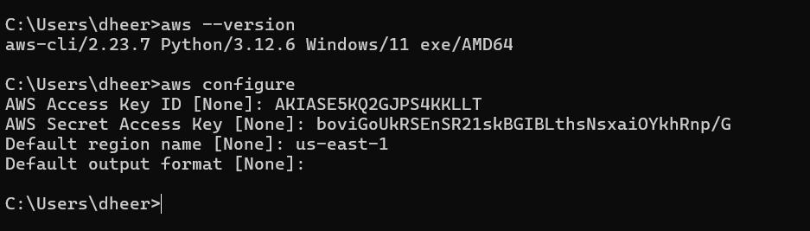

1. Initialize a bucket in s3 for the backend state store using Terraform. This bucket will be used later in this project to use the state files of Terraform.

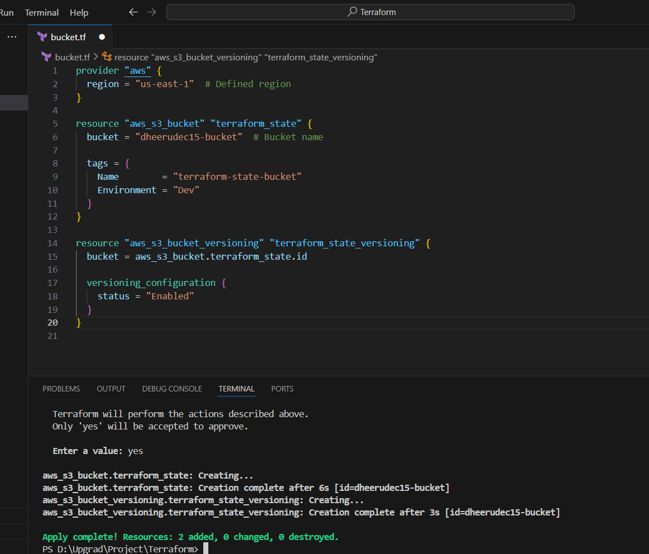



**Sub Task 2:**

1. VPC creation

Terraform code:

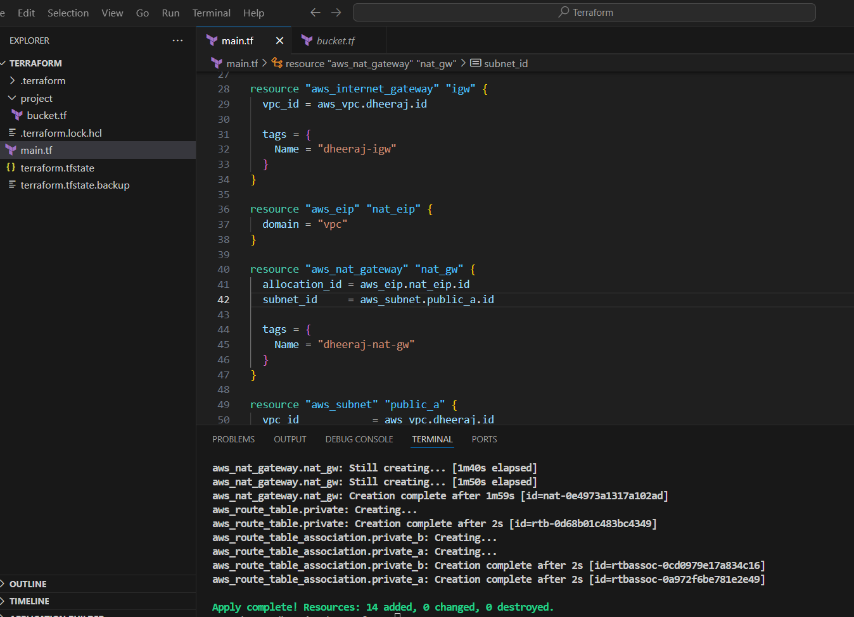

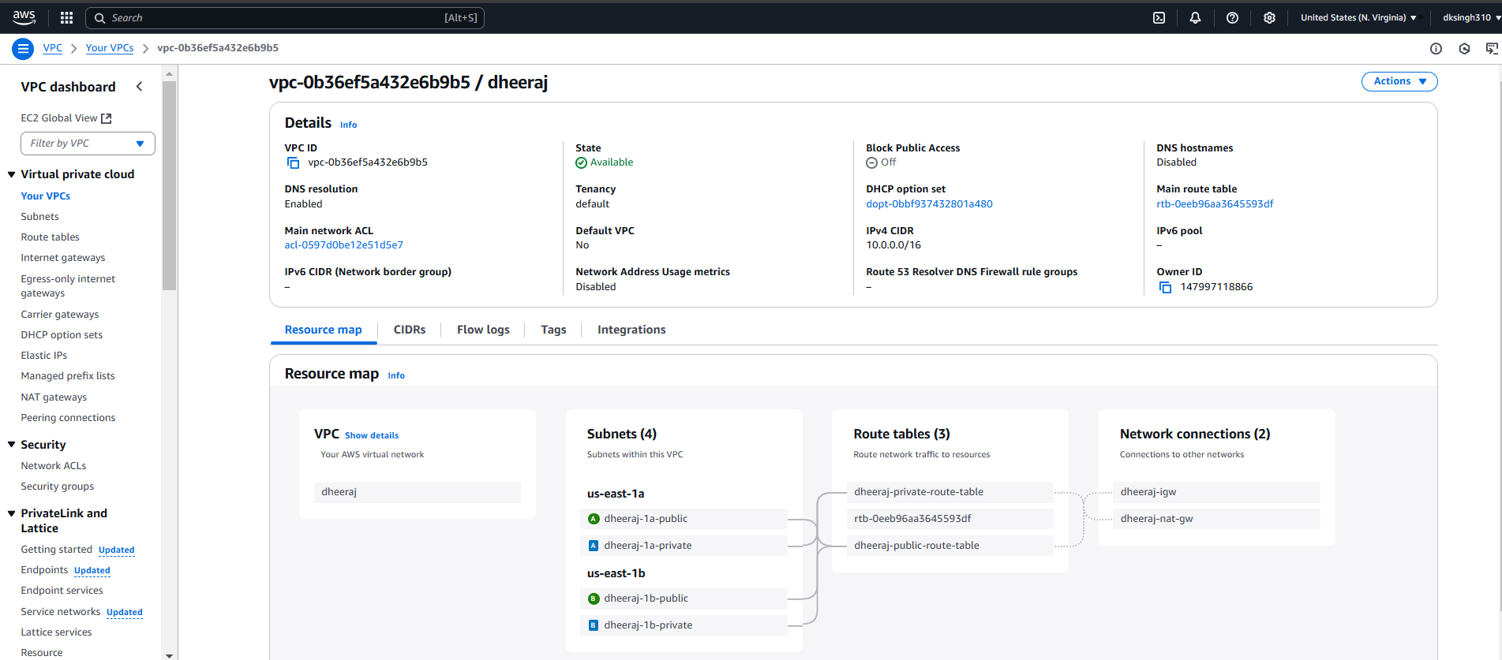

Subtask 3:

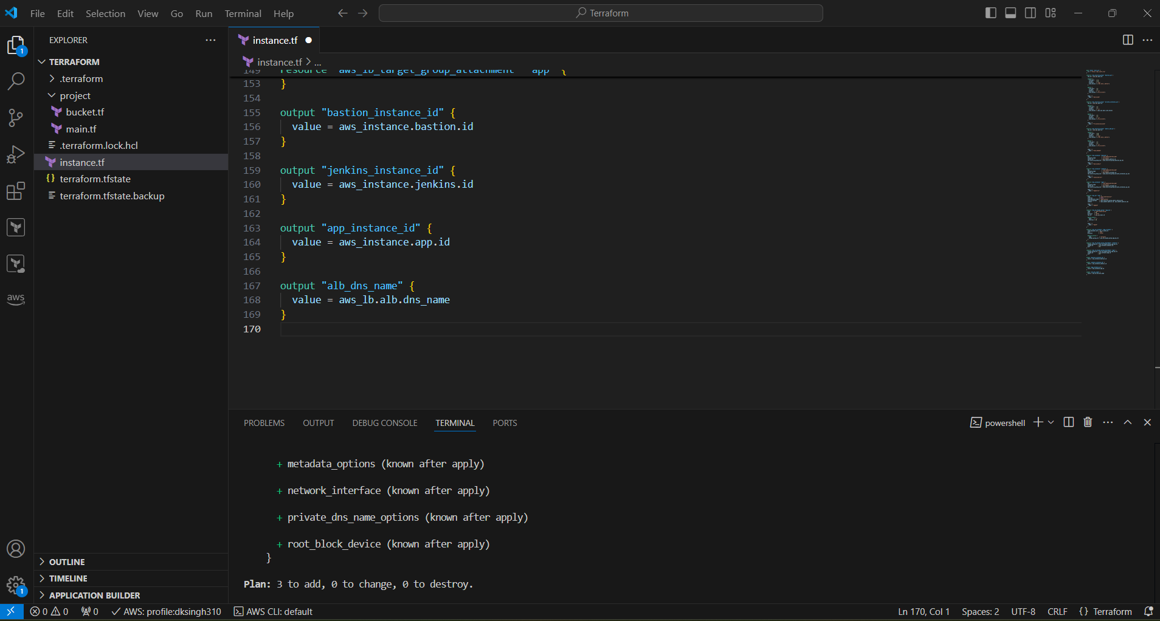

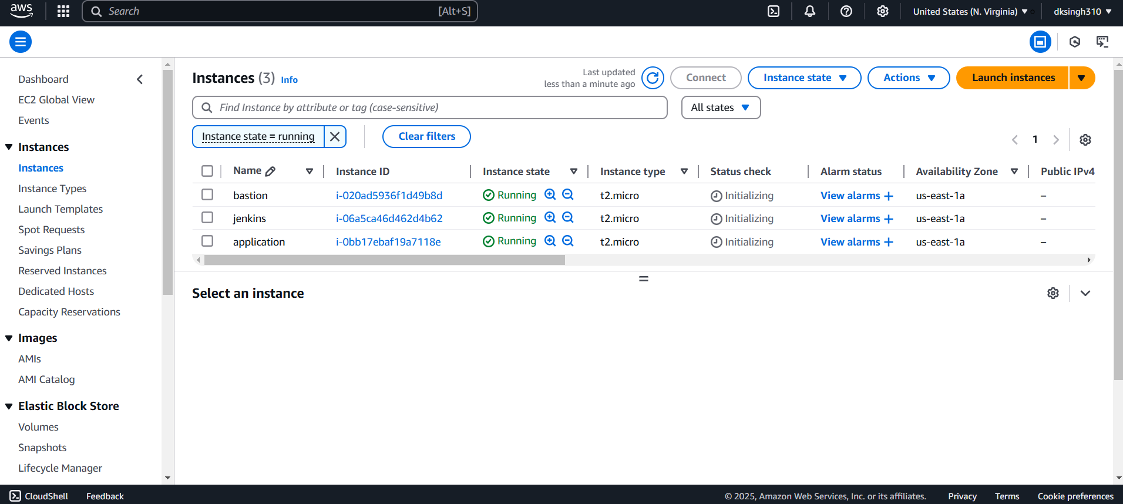

**Task 2:**

**Subtask 1:**

Install Ansible

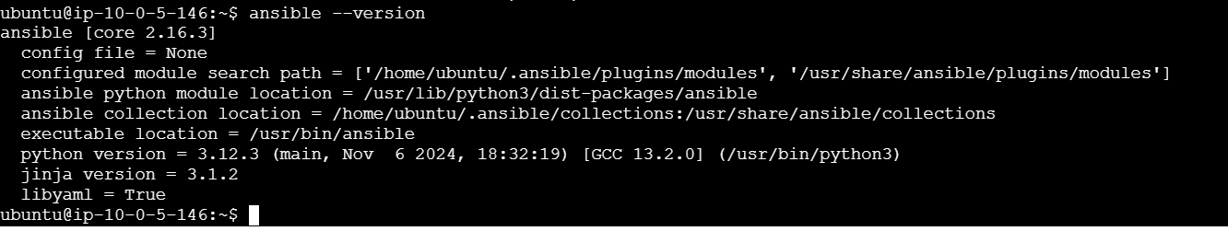

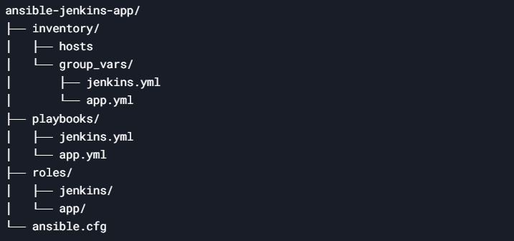

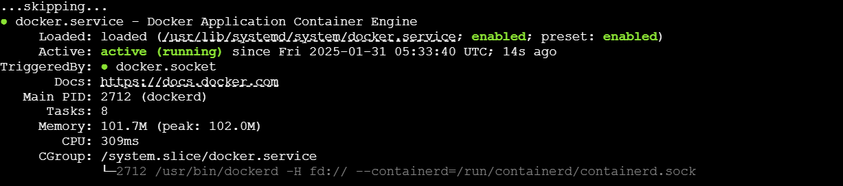



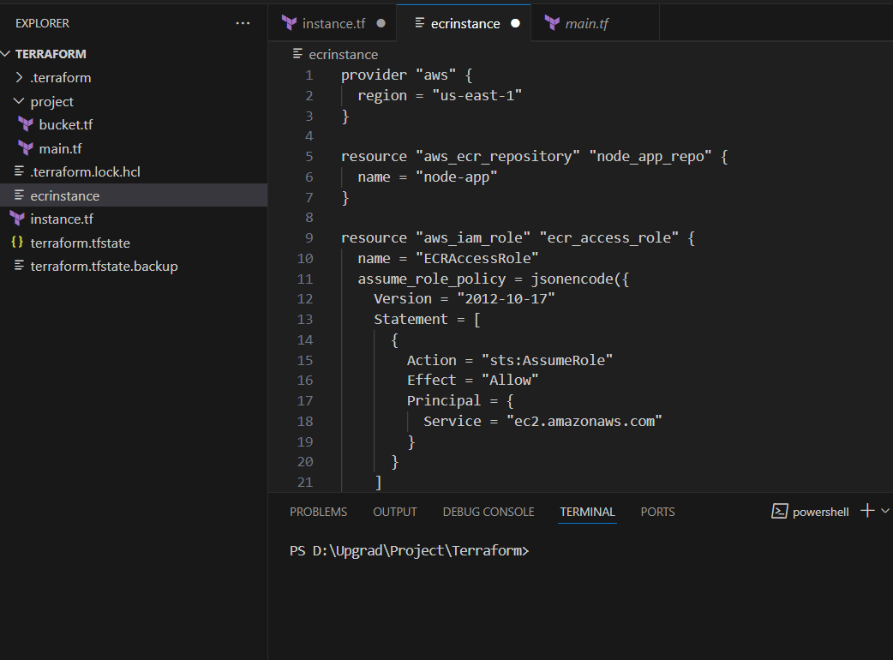

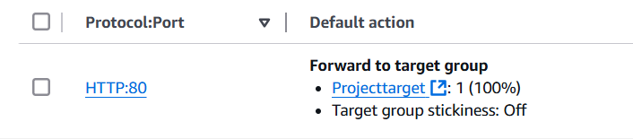

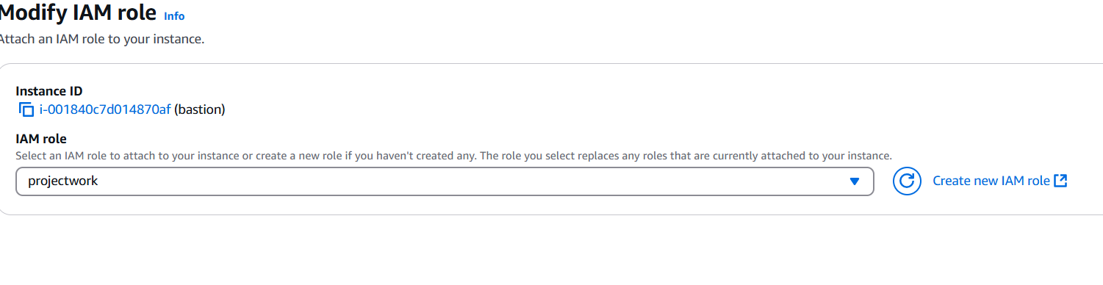

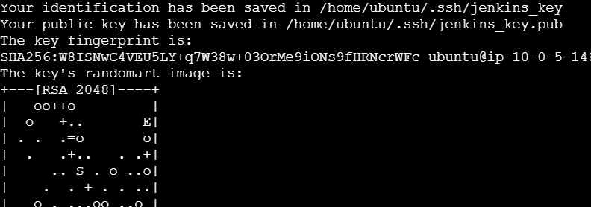

**TASK 3**



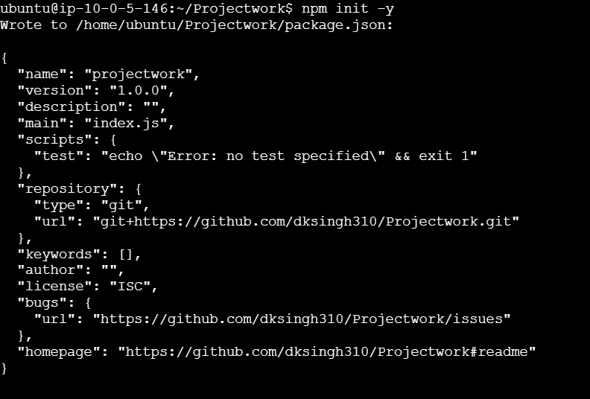

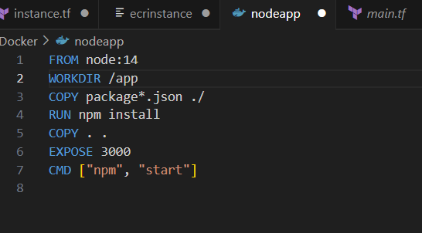

Vim nodeapp

docker build -t nodeapp .

docker run -p 3000:3000 nodeapp

Choosing <https://github.com/dipesh017/example-voting-app>

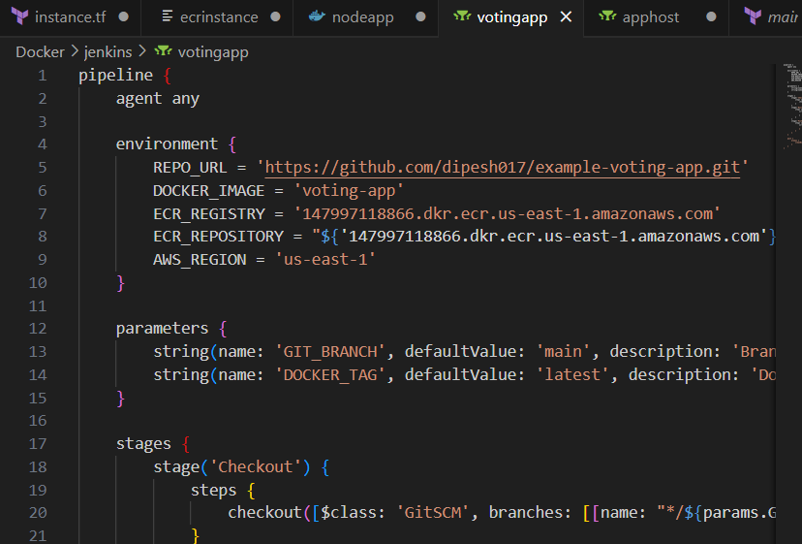

https://github.com/dksingh310/projectwork1